PROJECT NAME: ONLINE FOOD ORDERING & RESTAURANT MANAGEMENT SYSTEM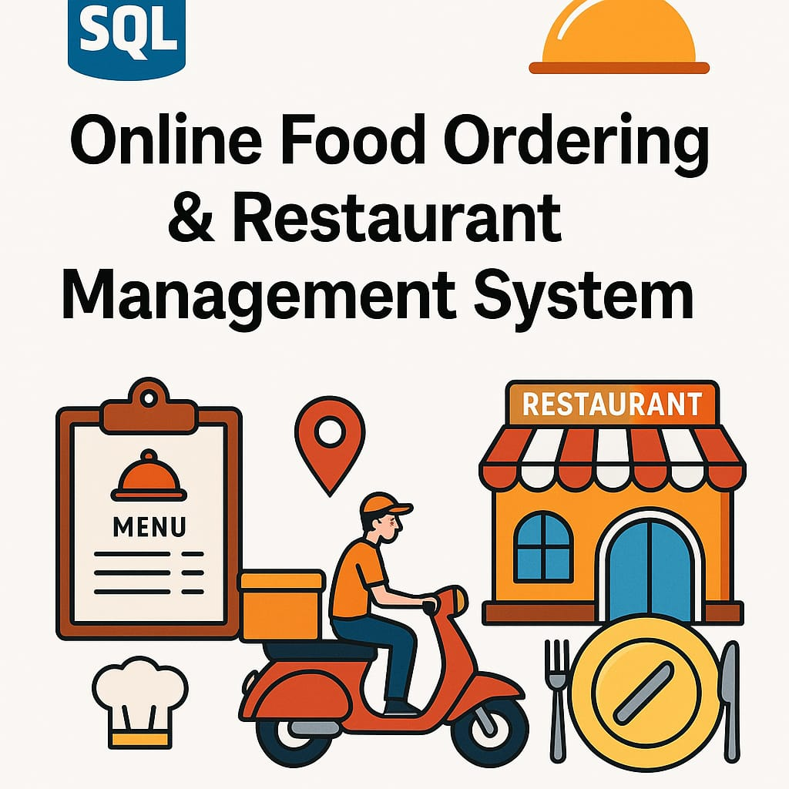

INTRODUCTION

The Online Food Ordering & Restaurant Management System is an SQL-based project that manages customer orders, restaurant menus, and delivery operations. It aims to simulate a food delivery platform like Zomato or Swiggy. The system focuses on storing and retrieving data related to:
- Customers
- Restaurants
- Menu Items
- Orders
- Ordered Items
The objective is to allow efficient tracking of:
- What food was ordered
- Who ordered it
- From which restaurant
- Total amounts
- Order statuses
This project showcases how SQL can be used in a real-world context to:
- Perform joins
- Filter and sort data
- Calculate aggregates (totals, averages)
- Manage relationships using foreign keys

ER DIAGRAM
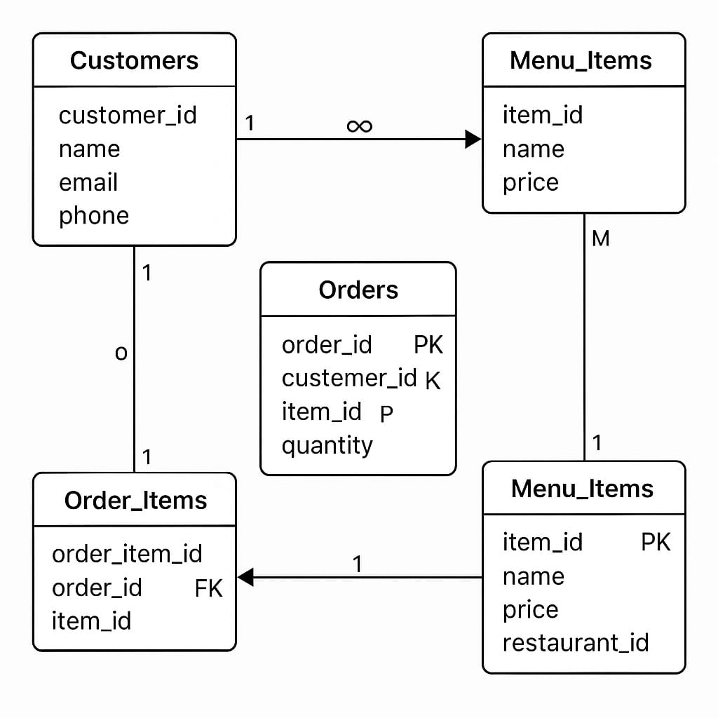
DDL :- DATA DEFINATION LANGUAGE
1.CREATE TABLE
1. RESTAURANTS
CREATE TABLE Restaurants (restaurant_id INT PRIMARY KEY AUTO_INCREMENT,name VARCHAR(100),address TEXT,contact_number VARCHAR(15),rating FLOAT,is_open BOOLEAN);
Desc restaurants;

2.CUSTOMERS
CREATE TABLE Customers (customer_id INT PRIMARY KEY,name VARCHAR(100),phone VARCHAR(15),address TEXT);
desc customers;
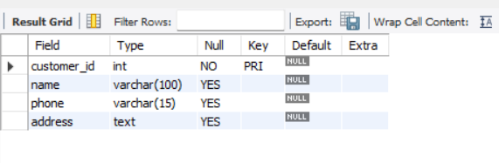
3. Menu_Items
CREATE TABLE Menu_Items (item_id INT PRIMARY KEY AUTO_INCREMENT,restaurant_id INT,item_name VARCHAR(100),category VARCHAR(50),price DECIMAL(8,2),is_available BOOLEAN,FOREIGN KEY (restaurant_id) REFERENCES Restaurants(restaurant_id));
Desc menu_items;

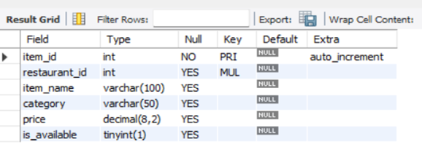
4. Orders
CREATE TABLE Orders (order_id INT PRIMARY KEY AUTO_INCREMENT,customer_id INT,restaurant_id INT,order_date DATE,order_time TIME,total_amount DECIMAL(10,2),status VARCHAR(50),FOREIGN KEY (customer_id) REFERENCES Customers(customer_id),FOREIGN KEY (restaurant_id) REFERENCES Restaurants(restaurant_id));
Desc orders
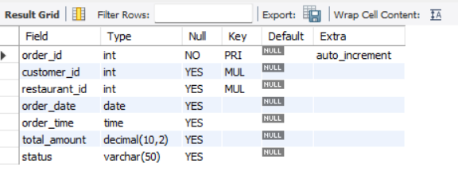
5.order_items
CREATE TABLE Order_Items (order_item_id INT PRIMARY KEY AUTO_INCREMENT,order_id INT,item_id INT,quantity INT,item_price DECIMAL(8,2),FOREIGN KEY (order_id) REFERENCES Orders(order_id),FOREIGN KEY (item_id) REFERENCES Menu_Items(item_id));
Desc order_items;

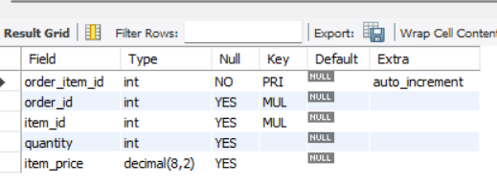

2.ALTER TABLE:
ALTER TABLE: ADD COLUM
Alter table customers add email_id varchar(60);
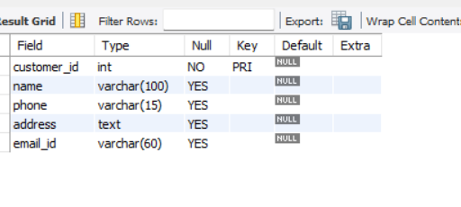
ALTER TABLE: MODIFY TABLE
ALTER TABLE Restaurants modify address varchar(50);
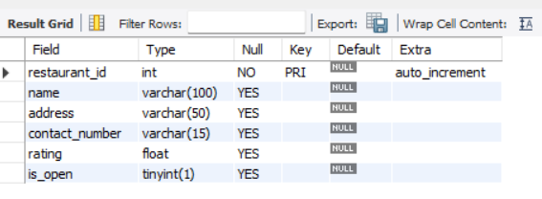
ALTER TABLE : RENAME COLUMN
ALTER table Restaurants RENAME COLUMN NAME TO REVEIWS;
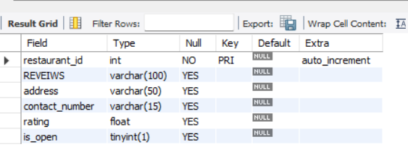
ALTER TABLE: DROP COLUMN
ALTER TABLE RESTAURANTS DROP COLUMN CONTACT_NUMBER;
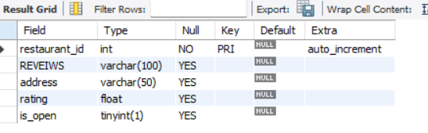
3.TRUNCATE TABLE :
TRUNCATE TABLE RESTRO;
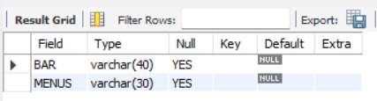

DROP TABLE:
DROP table RESTRO;

DATA MANIPULATION LANGUAGE (DML):
1.INSERT
INSERT INTO Restaurants (namess, address, rating, is_open) VALUES
('Spice Villa', 'Mumbai', 4.5, TRUE),
select * from Restaurants;
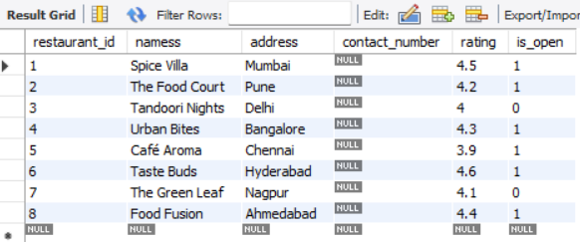

INSERT INTO Customers ( customer_id,named, phone, address, email_id) VALUES
(101,'Amit Kumar', '9876543210', 'Mumbai', 'amit@gmail.com'),

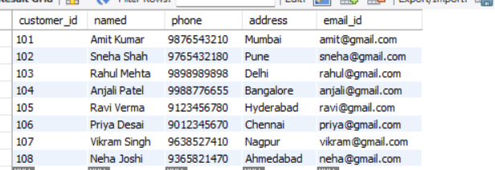

2.UPDATE IN TO TABLE
UPDATE Menu_Items SET price = 199.99 WHERE item_id = 3; 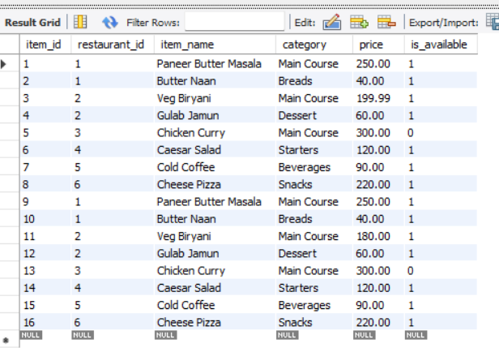

3.DATA QUERY LANGUAGE (DQL) :

1.Select Query:
(SELECT QUERY FOR ENTIRE DATA)
SELECT * FROM CUSTOMERS;
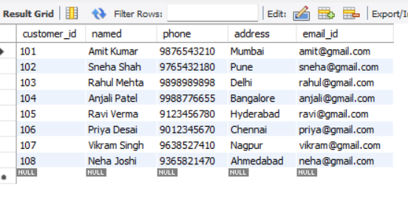
(SELECT SPECIFIC DATA)
SELECT ITEM_NAME, PRICE FROM MENU_ITEMS;
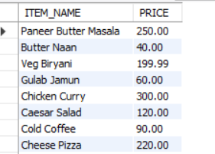

(Select query with changing Column name)
SELECT CATEGORY AS CATEGORIES FROM MENU_ITEMS;

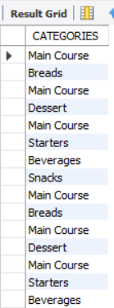

2.Order by
SELECT item_name, price FROM Menu_Items ORDER BY price DESC; 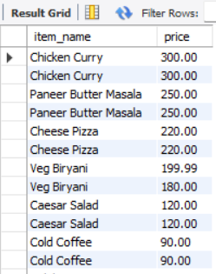

3.LIMIT QUERY
SELECT * FROM Orders ORDER BY order_date DESC LIMIT 5;
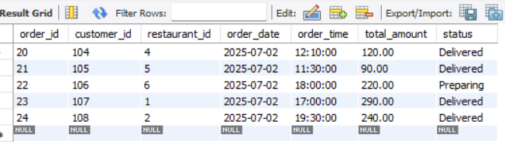
4.DISTINCT QUERY:
SELECT DISTINCT order_date FROM Orders;
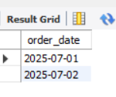
5.Where Clause:
1)With Comparison Operator
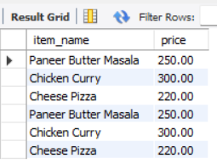

2)Using AND Operator

SELECT item_name, price FROM Menu_Items WHERE price >= 150 AND price <= 300;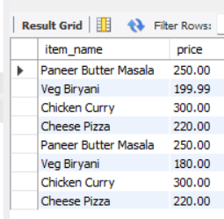
3) Using NOT Operator
SELECT * FROM Menu_Items WHERE restaurant_id NOT IN (1, 3); 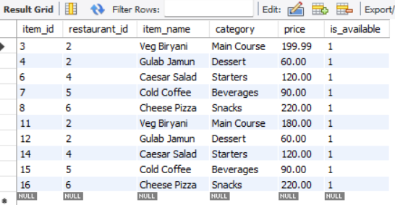
4)USING BETWEEN OPERATOR
SELECT item_name, price
FROM Menu_Items
WHERE price BETWEEN 200 AND 300;
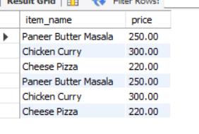

5) USING IN OPERATOR
SELECT * FROM Menu_Items WHERE category IN ('Beverages', 'Main Course'); 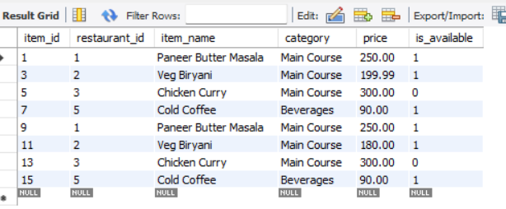
Count Function:
SELECT COUNT(*) AS total_customers FROM Customers;
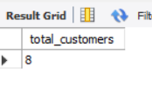
AVERAGE FUNCTION:
SELECT AVG(price) AS average_menu_price FROM Menu_Items; 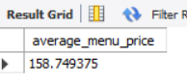

SUM FUNCTION:
SELECT SUM(total_amount) AS total_sales FROM Orders;
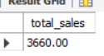
MIN MAX FUNCTION:
SELECT MIN(price) AS cheapest_item, MAX(price) AS costliest_item FROM Menu_Items;
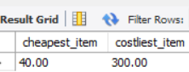

GROUP BY CLAUSE
SELECT customer_id, COUNT(*) AS total_orders FROM Orders GROUP BY customer_id;
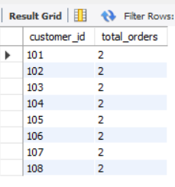
HAVING CLAUSE
SELECT category, AVG(price) AS avg_price FROM Menu_Items GROUP BY category
HAVING AVG(price) > 200;
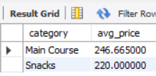
LIKE OPERATOR:
SELECT * FROM Menu_Items WHERE item_name LIKE 'Ch%'; 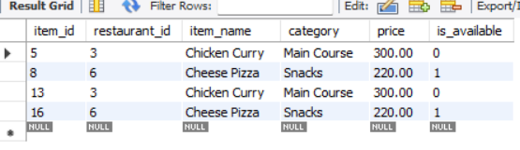
JOINS:
SELECT c.customer_id, c.named, o.order_id, o.order_date, o.total_amount
FROM Customers AS c JOIN Orders AS o ON c.customer_id = o.customer_id; 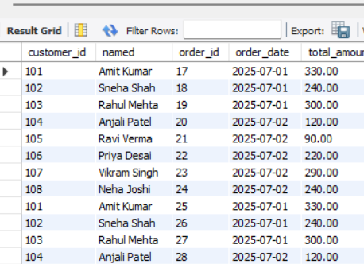

SUB QUERIES:
- SINGLE ROW SUB QUERY
SELECT named
FROM Customers
WHERE customer_id = (SELECT customer_id FROM Orders ORDER BY total_amount DESC LIMIT 1);

- MULTIPLE ROW SUB QUERY
SELECT named FROM Customers WHERE customer_id IN (SELECT customer_id FROM Orders);

- MULTIPLE COLUMN SUB QUERY
SELECT namesS FROM Restaurants WHERE restaurant_id = (SELECT restaurant_id FROM Menu_Items ORDER BY price DESC LIMIT 1);
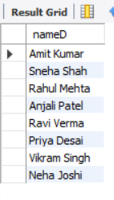
VEIWS
CREATE VIEW High_Value_OrdersS AS
SELECT order_id, customer_id, total_amount
FROM Orders
WHERE total_amount > 300;
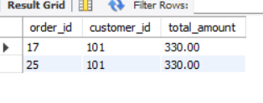
SELECT * FROM High_Value_OrdersS;
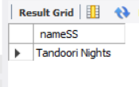

===============================END 0F PROJECT===============================

